Name:________________________
Write each number in words (I3, 4)
- 854
- 10,059
- 691.4
- .3481

Estimate and find the actual answer (I4, 5)
5. 5.32 x 2.01
6. 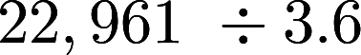
7. 728.6 x 12.3

Solve (4)
8. 2 + 6 x 3 + 1
9. 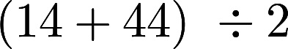
10. 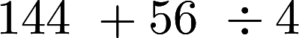

Write each number in standard form (I3)

11. Two hundred sixteen
12. Two hundred twenty-two thousandths

Find each quotient. DON’T USE REMAINDERS (NS)
13.
14.
15. 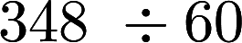

16. Find the mean median mode and range (I4, 5)
35, 39, 27, 28, 22, 27, 100, 12, 193

Write the rule and find the next three terms for the following (I4, 5)

17. 1, 4, 16, 64, …..
18. 2, 6, 18, 54….
19. 80, 74, 68, 62….

Evaluate each expression for n=9 (6)

20. N-7
21. 3n-5
22.
Write an expression for each word phrase. (5)

23. 1 less than b
24. 4 more than b
25. N divided by 2
26. N less than 12

Solve each equation. (6)

27. B + 4=7.7
28. N - 1.7=8
29. C + 3.5=7.5
30. 15t =600
31. 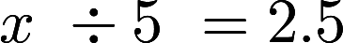
32. 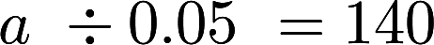

(I4, 5) Test each number for divisibility by
2,3,5,9,10
33. 324
34. 2,685
35. 114
36. 981

Find the GCF of each set of numbers (I4,5)

37. 15, 18
38. 8,12,20
39. 28,36

Find the LCM (I4,5)

40. 4,8
41. 6,14
42. 20,36

Solve (5)
43. 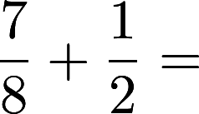

44. 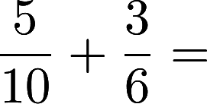

45. 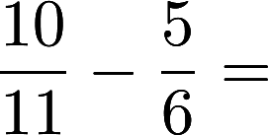

46. 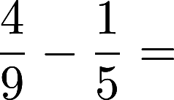

47. 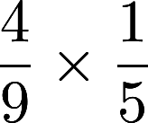

48. 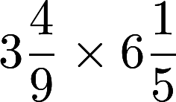

49. 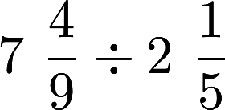

Write two different ratios equal to the following. (5)

50. 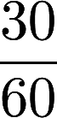

51. 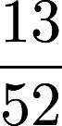

Do the following form a proportion? (6)

52. 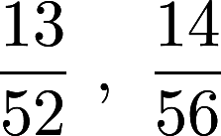

53. 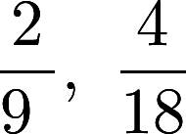

54. 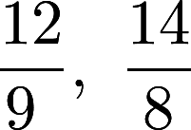

55. - 65. Find the fraction, decimal, and percent of each number (I4, 5)
1/2 |  |  |  | 1/5
 | 53% |  | 40%
 |  | .16
Find the actual distance. Use a scale drawing of 1 cm = 57 meters (6)

66. 3.5 cm
67. 0.7 cm

Find the percent of a number (I4,5)

68. 20% of 80
69. 15% of 22.5
70. 54% of 84

