Lesson 1

Problem 1
An elevator travels 310 feet in 10 seconds. At that speed, how far can this elevator travel in 12 seconds? Explain your reasoning.

Solution
327 feet. 310÷10=31, so the elevator travels 31 feet per second. and 31⋅12=327.

Problem 2
Han earns $33.00 for babysitting 4 hours. At this rate, how much will he earn if he babysits for 7 hours? Explain your reasoning.

Solution
He will earn $57.75 in 7 hours. 33÷4=8.25, so the hourly rate is $8.25. If he earns $8.25 every hour, he will earn 8.25⋅7 or $57.75.

Problem 3
The cost of 5 cans of dog food is $4.35. At this price, how much do 11 cans of dog food cost? Explain your reasoning.

Solution
11 cans cost $9.57. 4.35÷5=0.87, so each can costs 87 cents, and 0.87⋅11=9.57.

Problem 4
A restaurant has 26 tables in its dining room. It takes the waitstaff 10 minutes to clear and set 4 tables. At this rate, how long will it take the waitstaff to clear and set all the tables in the dining room? Explain or show your reasoning.

Solution
It will take 65 minutes, or 1 hour and 5 minutes. Sample strategy:
 | number of tables | time in minutes
row 1 | 4 | 10
row 2 | 1 | 2.5
row 3 | 26 | 65

Problem 5
(from Unit 2, Lesson 16)
A sandwich shop serves 4 ounces of meat and 3 ounces of cheese on each sandwich. After making sandwiches for an hour, the shop owner has used 91 combined ounces of meat and cheese.
- How many combined ounces of meat and cheese are used on each sandwich?
- How many sandwiches were made in the hour?
- How many ounces of meat were used?
- How many ounces of cheese were used?

Solution
- 7 ounces
- 13 sandwiches
- 52 ounces of meat
- 39 ounces of cheese

Problem 6
(from Unit 2, Lesson 14)
Here is a flower made up of yellow hexagons, red trapezoids, and green triangles.
- How many copies of this flower pattern could you build if you had 30 yellow hexagons, 50 red trapezoids, and 60 green triangles?
- Of which shape would you have the most left over?

Solution
I could build 5 copies of the flower pattern, because that would use all 30 of the yellow hexagons. I would have 40 red trapezoids left over.

Problem 7
(from Unit 1, Lesson 16)
Match each quantity in the first list with an appropriate unit of measurement from the second list.
- the perimeter of a baseball field
- the area of a bed sheet
- the volume of a refrigerator
- the surface area of a tissue box
- the length of a spaghetti noodle
- the volume of a large lake
- the surface area of the the moon
- centimeters (cm)
- cubic feet (cu ft)
- cubic kilometers (cu km)
- meters (m)
- square feet (sq ft)
- square inches (sq in)
- square kilometers (sq km)

Solution
- E
- C
- F
- A
- B
- D
- G

Lesson 2

Problem 1
Select the unit from the list that you would use to measure each object.
- The length of a pencil
- The weight or mass of a pencil
- The volume of a pencil
- The weight or mass of a hippopotamus
- The length of a hippopotamus
- The length of a fingernail clipping
- The weight or mass of a fingernail clipping
- The volume of a sink
- The volume of a bowl
- The length of a chalkboard or whiteboard
- The weight or mass of a chalkboard or whiteboard
- The length of the border between the United States and Canada
- centimeters
- cups
- feet
- gallons
- grams
- inches
- kilograms
- kilometers
- liters
- meters
- miles
- milliliters
- millimeters
- ounces
- pounds
- quarts
- tons
- yards

Solution
Answers Vary. Possible responses:
- inches, centimeters
- grams, ounces
- millimeters
- pounds, kilograms, tons
- feet, yards, meters
- millimeters
- grams
- gallons, liters, quarts
- cups, liters, quarts
- feet. yards, meters
- kilograms, pounds
- kilometers, miles

Problem 2
When this pet hamster is placed on a digital scale, the scale reads 1.5.
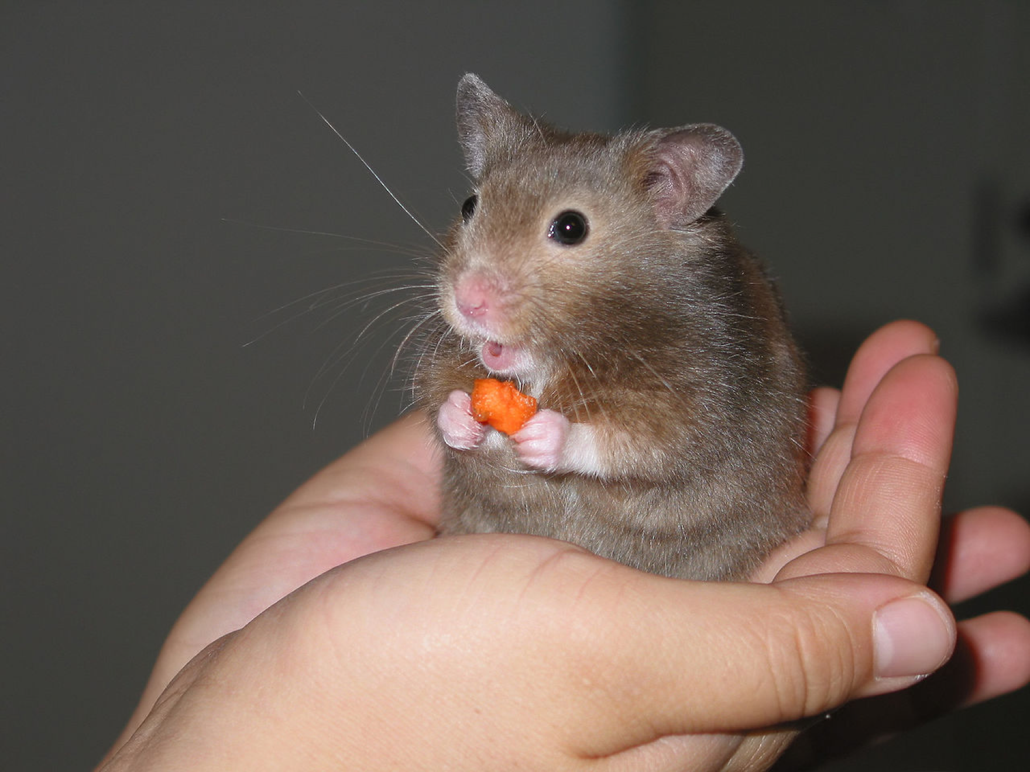
What could be the units?

Solution
Ounces. (Grams and milligrams are too small. Pounds and kilograms are too big.)

Problem 3
Circle the larger unit of measure. Then, determine if the unit measures distance, volume, or weight (mass).
- meter or kilometer
- yard or foot
- cup or quart
- pound or ounce
- liter or milliliter
- gram or kilogram

Solution
- Kilometer, distance
- Yard, distance
- Quart, volume
- Pound, weight (mass)
- Liter, volume
- Kilogram, weight (mass)

Problem 4
(from Unit 2, Lesson 15)
Elena mixes 5 cups of apple juice with 2 cups of sparkling water to make sparkling apple juice. For a party, she wants to make 35 cups of sparkling apple juice. How much of each ingredient should Elena use? Explain or show your reasoning.

Solution
25 cups of apple juice and 10 cups of sparkling water. Possible strategies:
- There are 7 cups of sparkling juice in each batch, since 5+2=7. To make 35 cups Elena will need 5 batches since 5⋅7=35. 5 batches mean 25 cups of apple juice and 10 cups of sparkling water.
- Tape diagram:
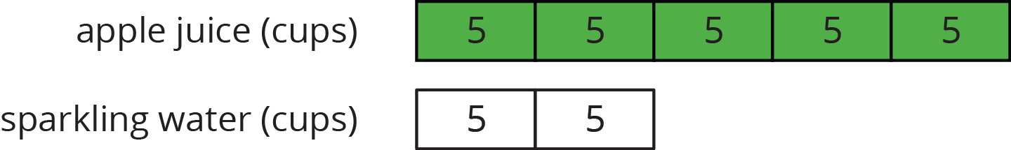

Problem 5
(from Unit 2, Lesson 12)
Lin bought 3 hats for $22.50. At this rate, how many hats could she buy with $60.00? If you get stuck, try using the table.
 | number of hats | price in dollars
row 1
row 2
row 3
row 4

Solution
8 hats. Sample reasoning:
 | number of hats | price in dollars
row 1 | 3 | 22.50
row 2 | 1 | 7.50
row 3 | 5 | 37.50
row 4 | 8 | 60

Problem 6
(from Unit 2, Lesson 9)
Light travels about 180 million kilometers in 10 minutes. How far does it travel in 1 minute? How far does it travel in 1 second? Show your reasoning.

Solution
Light travels about 18 million km in 1 minute. 18,000,000÷60=300,000, so light travels about 300,000 km in one second.

Lesson 3

Problem 1
(from Unit 3, Lesson 2)
Decide if each is a measurement of length, area, volume, or weight (or mass).
- How many centimeters across a handprint
- How many square inches of paper needed to wrap a box
- How many gallons of water in a fish tank
- How many pounds in a bag of potatoes
- How many feet across a swimming pool
- How many ounces in a bag of grapes
- How many liters in a punch bowl
- How many square feet of grass in a lawn

Solution
- Length
- Area
- Volume
- Weight (or mass)
- Length
- Weight (or mass)
- Volume
- Area

Problem 2
Clare says, “This classroom is 11 meters long. A meter is longer than a yard, so if I measure the length of this classroom in yards, I will get less than 11 yards.” Do you agree with Clare? Explain your reasoning.

Solution
Clare is incorrect. Explanations vary. Sample explanation: Since yards are shorter than meters, more yards than meters are needed to measure the same length.

Problem 3
Tyler’s height is 57 inches. What could be his height in centimeters? Explain your reasoning.
- 22.4
- 57
- 144.8
- 3,551

Solution
C
There are about 2.5 centimeters in every inch and 2.5⋅50=125, so option C is the best choice.

Problem 4
A large soup pot holds 20 quarts. What could be its volume in liters?
- 7.57
- 19
- 21
- 75.7

Solution
B
One liter is slightly larger than a quart, so it takes slightly fewer liters than quarts to measure the same volume.

Problem 5
Clare wants to mail a package that weighs 412 pounds. What could this weight be in kilograms?
- 2.04
- 4.5
- 9.92
- 4,500

Solution
A
One kilogram weighs more than one pound, so it takes fewer kilograms than pounds to measure Clare’s package.

Problem 6
(from Unit 2, Lesson 13)
Noah bought 15 baseball cards for $9.00. Assuming each baseball card costs the same amount, answer the following questions.
- At this rate, how much will 30 baseball cards cost? Explain your reasoning.
- At this rate, how much will 12 baseball cards cost? Explain your reasoning.
- Do you think this information would be better represented using a table or a double number line? Explain your reasoning.

Solution
- $18.00, because 30 is twice as much as 15 and 18 is twice as much as 9.
- $7.20, because each baseball card costs 60 cents, and 0.6 times 12 is 7.2.
- Answers vary. Sample response: A table would be more convenient, because the rows of the table can be listed in any order, and not all values between the ones needed have to be filled in.

Problem 7
(from Unit 2, Lesson 9)
Jada traveled 135 miles in 3 hours. Andre traveled 228 miles in 6 hours. Both Jada and Andre traveled at a constant speed.
- How far did Jada travel in 1 hour?
- How far did Andre travel in 1 hour?
- Who traveled faster? Explain or show your reasoning.

Solution
- Jada traveled 45 miles per hour because 135÷3=45.
- Andre traveled 38 miles per hour because 228÷6=38.
- Jada traveled faster because she covered a greater distance in the same amount of time.

Lesson 4

Problem 1
Priya’s family exchanged 250 dollars for 4,250 pesos. Priya bought a sweater for 510 pesos. How many dollars did the sweater cost?
 | pesos | dollars
row 1 | 4,250 | 250
row 2 |  | 25
row 3 |  | 1
row 4 |  | 3
row 5 | 510

Solution
30 dollars

Problem 2
There are 3,785 milliliters in 1 gallon, and there are 4 quarts in 1 gallon. For each question, explain or show your reasoning.
- How many milliliters are in 3 gallons?
- How many milliliters are in 1 quart?

Solution
- 11,355 milliliters, because 3,785⋅3=11,355.
- 946.25 milliliters, because 3,785÷4=346.25

Problem 3
Lin knows that there are 4 quarts in a gallon. She wants to convert 6 quarts to gallons, but cannot decide if she should multiply 6 by 4 or divide 6 by 4 to find her answer. What should she do? Explain or show your reasoning. If you get stuck, consider drawing a double number line or using a table.

Solution
Lin should divide 6 by 4. Explanations vary. Sample explanations:
- A gallon is larger than a quart, so there are fewer than 6 gallons in 6 quarts.
- Table:
 | quarts | gallons
row 1 | 4 | 1
row 2 | 6 | 1.5

Problem 4
Tyler has a baseball bat that weighs 28 ounces. Find this weight in kilograms and in grams. (Note: 1 kilogram ≈ 35 ounces)

Solution
0.8 kilograms (28÷35=0.8) and 800 grams (0.8⋅1,000=800)

Problem 5
(from Unit 3, Lesson 1)
Identify whether each unit measures length, volume, or weight (mass).
- Mile
- Cup
- Pound
- Centimeter
- Liter
- Gram
- Pint
- Yard
- Kilogram
- Teaspoon
- Milliliter

Solution
- Length
- Volume
- Weight (mass)
- Length
- Volume
- Weight (mass)
- Volume
- Length
- Weight (mass)
- Volume
- Volume

Problem 6
(from Unit 2, Lesson 11)
A recipe for trail mix uses 7 ounces of almonds with 5 ounces of raisins. (Almonds and raisins are the only ingredients.) How many ounces of almonds would be in a one-pound bag of this trail mix? Explain or show your reasoning.

Solution
283=913, so there are 913 ounces of almonds. There are multiple ways to find this, and one way is to know the original mix has 12 ounces and multiply by 1612=43 to produce an equivalent ratio for a 16-ounce mix.

Problem 7
(from Unit 2, Lesson 9)
An ant can travel at a constant speed of 980 inches every 5 minutes.
- How far does the ant travel in 1 minute?
- At this rate, how far can the ant travel in 7 minutes?

Solution
- 196 inches per minute because 980÷5=196.
- 1,372 inches because 196 times 7 is 1,372.

Lesson 5

Problem 1
Mai and Priya were on scooters. Mai traveled 15 meters in 6 seconds. Priya travels 22 meters in 10 seconds. Who was moving faster? Explain your reasoning.

Solution
Mai’s scooter is faster. 22÷10=2.2, so Priya’s scooter travels at a rate of 2.2 meters per second. 15÷6=2.5, so Mai’s scooter travels at a rate of 2.5 meters per second.

Problem 2
Here are the prices for cans of juice that are the same brand and the same size at different stores. Which store offers the best deal? Explain your reasoning.
Store X: 4 cans for $2.48
Store Y: 5 cans for $3.00
Store Z: 59 cents per can

Solution
Store Z has the best deal. 2.48÷4=0.62 or 62 cents per can. 3÷5=0.6 or 60 cents per can. 59 cents is the least expensive of the 3 options.

Problem 3
Costs of homes can be very different in different parts of the United States.
- A 450-square-foot apartment in New York City costs $540,000. What is the price per square foot? Explain or show your reasoning.
- A 2,100-square-foot home in Cheyenne, Wyoming, costs $110 per square foot. How much does this home cost? Explain or show your reasoning.

Solution
- $1,200 (540,000÷450=1,200)
- $231,000 (2,100⋅110=231,000)

Problem 4
(from Unit 3, Lesson 4)
There are 33.8 fluid ounces in a liter. There are 128 fluid ounces in a gallon. About how many liters are in a gallon?
- 2
- 3
- 4
- 5
Is your estimate larger or smaller than the actual number of liters in a gallon? Explain how you know.

Solution
C. Answers vary. Sample response: This estimate is too big: 4⋅32=128, so 4⋅(33.8) is larger than 128.

Problem 5
(from Unit 3, Lesson 3)
Diego is 165 cm tall. Andre is 1.7 m tall. Who is taller, Diego or Andre? Explain your reasoning.

Solution
Andre is taller. 1.7 m is 170 cm, and 170>165.

Problem 6
(from Unit 3, Lesson 2)
Name an object that could be about the same length as each measurement.
- 4 inches
- 6 feet
- 1 meter
- 5 yards
- 6 centimeters
- 2 millimeters
- 3 kilometers

Solution
Answers vary. Sample response:
- Pencil
- Ladder
- Person’s leg
- Tablecloth
- Insect
- Grain of rice
- Foot race

Lesson 6

Problem 1
A pink paint mixture uses 4 cups of white paint for every 3 cups of red paint.
The table shows different quantities of red and white paint for the same shade of pink. Complete the table.
 | white paint (cups) | red paint (cups)
row 1 | 4 | 3
row 2 |  | 1
row 3 | 1
row 4 |  | 4
row 5 | 5

Solution
Equivalent values are also acceptable.
 | white paint (cups) | red paint (cups)
row 1 | 4 | 3
row 2 | 43 | 1
row 3 | 1 | 34
row 4 | 163 | 4
row 5 | 5 | 154

Problem 2
A farm lets you pick 3 pints of raspberries for $12.00.
- What is the cost per pint?
- How many pints do you get per dollar?
- At this rate, how many pints can you afford for $20.00?
- At this rate, how much will 8 pints of raspberries cost?

Solution
- Each pint costs 123 or $4.
- You get 312 or 14 or 0.25 pints per dollar.
- You can afford 5 pints, because 20÷4=5 and (0.25)⋅20=5.
- 8 pints will cost $32.00, because 8⋅4=32. Possible strategy:
 | pints of raspberries | cost in dollars
row 1 | 3 | 12
row 2 | 1 | 4
row 3 | 14 | 1
row 4 | 5 | 20
row 5 | 8 | 32

Problem 3
Han and Tyler are following a polenta recipe that uses 5 cups of water for every 2 cups of cornmeal.
- Han says, “I am using 3 cups of water. I will need 115 cups of cornmeal.”
- Tyler says, “I am using 3 cups of cornmeal. I will need 712 cups of water.”
Do you agree with either of them? Explain your reasoning.

Solution
They are both correct. For every cup of water, 25 cup of cornmeal is used. For every cup of cornmeal, 212 cups of water are used.
 | water (cups) | cornmeal (cups)
row 1 | 5 | 2
row 2 | 1 | 25
row 3 | 212 | 1
row 4 | 3 | 115
row 5 | 712 | 3

Problem 4
A large art project requires enough paint to cover 1,750 square feet. Each gallon of paint can cover 350 square feet. Each square foot requires 1350 of a gallon of paint.
Andre thinks he should use the rate 1350 gallons of paint per square foot to find how much paint they need. Do you agree with Andre? Explain or show your reasoning.

Solution
Answers vary. Sample responses:
- I agree with Andre. He needs enough paint for 1,750 square feet. Since each square foot requires 1350 gallons of paint, Andre needs 5 gallons of paint because (1,750)⋅1350=5.
- I disagree with Andre. It is easier to use the rate 350 square feet per gallon. This table shows that he needs 5 gallons of paint:
 | gallons of paint | area in square feet
row 1 | 1 | 350
row 2 | 5 | 1,750

Problem 5
(from Unit 3, Lesson 5)
Andre types 208 words in 4 minutes. Noah types 342 words in 6 minutes. Who types faster? Explain your reasoning.

Solution
Noah types faster. He can type 5 more words per minute than Andre. Andre types at a rate of 52 words per minute, because 208÷4=52. Noah types at a rate of 57 words per minute, because 342÷6=57.

Problem 6
(from Unit 3, Lesson 5)
A corn vendor at a farmer's market was selling a bag of 8 ears of corn for $2.56. Another vendor was selling a bag of 12 for $4.32. Which bag is the better deal? Explain or show your reasoning.

Solution
The bag of 8 is better. 2.56÷8=0.32, so each ear of corn is 32 cents. In the bag of 12, each ear of corn is 36 cents because 4.32÷12=0.36.

Problem 7
(from Unit 3, Lesson 3)
A soccer field is 100 meters long. What could be its length in yards?
- 33.3
- 91
- 100
- 109

Solution
D
One yard is slightly shorter than a meter, so it takes slightly more yards than meters to measure the length of the same object.

Lesson 7

Problem 1
A car travels 55 miles per hour for 2 hours. Complete the table.
 | time (hours) | distance (miles) | miles per hour
row 1 | 1 | 55 | 55
row 2 | 12
row 3 | 112
row 4 |  | 110

Solution
 | time (hours) | distance (miles) | miles per hour
row 1 | 1 | 55 | 55
row 2 | 12 | 27.5 | 55
row 3 | 112 | 82.5 | 55
row 4 | 2 | 110 | 55

Problem 2
The table shows the amounts of onions and tomatoes in different-sized batches of a salsa recipe.
Elena notices that if she takes the number in the tomatoes column and divides it by the corresponding number in the onions column, she always gets the same result.
What is the meaning of the number that Elena has calculated?
 | onions (ounces) | tomatoes (ounces)
row 1 | 2 | 16
row 2 | 4 | 32
row 3 | 6 | 48

Solution
The recipe calls for 8 ounces of tomatoes per ounce of onions.

Problem 3
A restaurant is offering 2 specials: 10 burritos for $12, or 6 burritos for $7.50. Noah needs 60 burritos for his party. Should he buy 6 orders of the 10-burrito special or 10 orders of the 6-burrito special? Explain your reasoning.

Solution
Answers vary. Possible reasoning: Noah should get 6 orders of the 10-burrito special. The 10-burrito special sells burritos at a rate of $1.20 per burrito, because 12÷10=1.20. The 6-burrito special sells at a rate of $1.25 per burrito, because 7.5÷6=1.25. The 10-burrito special is a better deal.

Problem 4
Complete the table so that the cost per banana remains the same.
 | number of bananas | cost in dollars | unit price (dollars per banana)
row 1 | 4 |  | 0.50
row 2 | 6 |  | 0.50
row 3 | 7 |  | 0.50
row 4 | 10 |  | 0.50
row 5 |  | 10.00 | 0.50
row 6 |  | 16.50 | 0.50

Solution
 | number of bananas | cost in dollars | dollars per banana
row 1 | 4 | 2.00 | 0.50
row 2 | 6 | 3.00 | 0.50
row 3 | 7 | 3.50 | 0.50
row 4 | 10 | 5.00 | 0.50
row 5 | 20 | 10.00 | 0.50
row 6 | 33 | 16.50 | 0.50

Problem 5
(from Unit 3, Lesson 5)
Two planes travel at a constant speed. Plane A travels 2,800 miles in 5 hours. Plane B travels 3,885 miles in 7 hours. Which plane is faster? Explain your reasoning.

Solution
Plane A is faster. Plane A travels 2800÷5=560 or 560 miles per hour. Plane B travels 3,885÷7=555, or 555 miles per hour. Plane A travels a farther distance in one hour.

Problem 6
(from Unit 3, Lesson 6)
A car has 15 gallons of gas in its tank. The car travels 35 miles per gallon of gas. It uses 135 of a gallon of gas to go 1 mile.
- How far can the car travel with 15 gallons? Show your reasoning.
- How much gas does the car use to go 100 miles? Show your reasoning.

Solution
- 525 miles. Possible reasoning:
 | gallons of gas | miles car can travel
row 1 | 1 | 35
row 2 | 5 | 175
row 3 | 15 | 125
- 10035 (or 207 or 267) gallons. Possible reasoning:
 | gallons of gas | miles car can travel
row 1 | 135 | 1
row 2 | 1035 | 10
row 3 | 10035 | 100

Problem 7
(from Unit 3, Lesson 4)
A box of cereal weighs 600 grams. How much is this weight in pounds? Explain or show your reasoning. (Note: 1 kilogram = 2.2 pounds)

Solution
1.32 pounds. Explanations vary. Possible explanation:
 | grams | pounds
row 1 | 1,000 | 2.2
row 2 | 100 | 0.22
row 3 | 500 | 1.1
row 4 | 600 | 1.32
(Note that for the first line of the table, 1 kilogram is written as 1,000 grams.)

Lesson 8

Problem 1
A kangaroo hops 2 kilometers in 3 minutes. At this rate:
- How long does it take the kangaroo to travel 5 kilometers?
- How far does the kangaroo travel in 2 minutes?

Solution
- 7.5 minutes (or equivalent)
- 43 kilometers (or equivalent)

Problem 2
Mai runs around a 400-meter track at a constant speed of 250 meters per minute. How many minutes does it take Mai to complete 4 laps of the track? Explain or show your reasoning.

Solution
325 minutes (or equivalent). Possible responses:

 | distance (meters) | time (minutes)
row 1 | 250 | 1
row 2 | 500 | 2
row 3 | 400 | 1.6
row 4 | 1,600 | 6.4
- If each lap is 400 meters, then Mai runs 1,600 meters in 4 laps. Since every 250 meters takes her 1 minute to run, it would take her 1,600÷250 or 6.4 minutes to run 1,600 meters.

Problem 3
At 10:00 a.m., Han and Tyler both started running toward each other from opposite ends of a 10-mile path along a river. Han runs at a pace of 12 minutes per mile. Tyler runs at a pace of 15 minutes per mile.
- How far does Han run after a half hour? After an hour?
- Do Han and Tyler meet on the path within 1 hour? Explain or show your reasoning.

Solution
- Han runs 212 miles in a half hour and 5 miles in an hour. This table can be used to determine the distances.
 | time (minutes) | distance (miles)
row 1 | 12 | 1
row 2 | 1 | 112
row 3 | 30 | 212
row 4 | 60 | 5

- No. Tyler travels 1 mile every 15 minutes, so he travels 4 miles in 60 minutes. Because Han travels 5 miles and Tyler travels 4 miles, and they are 10 miles apart, they are one mile apart after 1 hour.

Problem 4
(from Unit 2, Lesson 16)
Two skateboarders start a race at the same time. Skateboarder A travels at a steady rate of 15 feet per second. Skateboarder B travels at a steady rate of 22 feet per second. After 4 minutes, how much farther will Skateboarder B have traveled? Explain your reasoning.

Solution
Skateboarder B will have traveled 1,680 feet farther. Possible reasoning: There are 240 seconds in 4 minutes, because 4⋅60=240. Skateboarder A travels 240 times 15, or 3,600 feet in 4 minutes. Skateboarder B travels 240 times 22, or 5,280 feet in 4 minutes, because 5280−3600=1680.

Problem 5
(from Unit 3, Lesson 4)
There are 4 tablespoons in 14 cup. There are 2 cups in 1 pint. How many tablespoons are there in 1 pint? If you get stuck, consider drawing a double number line or making a table.

Solution
32 tablespoons

Problem 6
(from Unit 1, Lesson 12)
Two larger cubes are made out of unit cubes. Cube A is 2 by 2 by 2. Cube B is 4 by 4 by 4. The side length of Cube B is twice that of Cube A.
- Is the surface area of Cube B also twice that of Cube A? Explain or show your reasoning.
- Is the volume of Cube B also twice that of Cube A? Explain or show your reasoning.
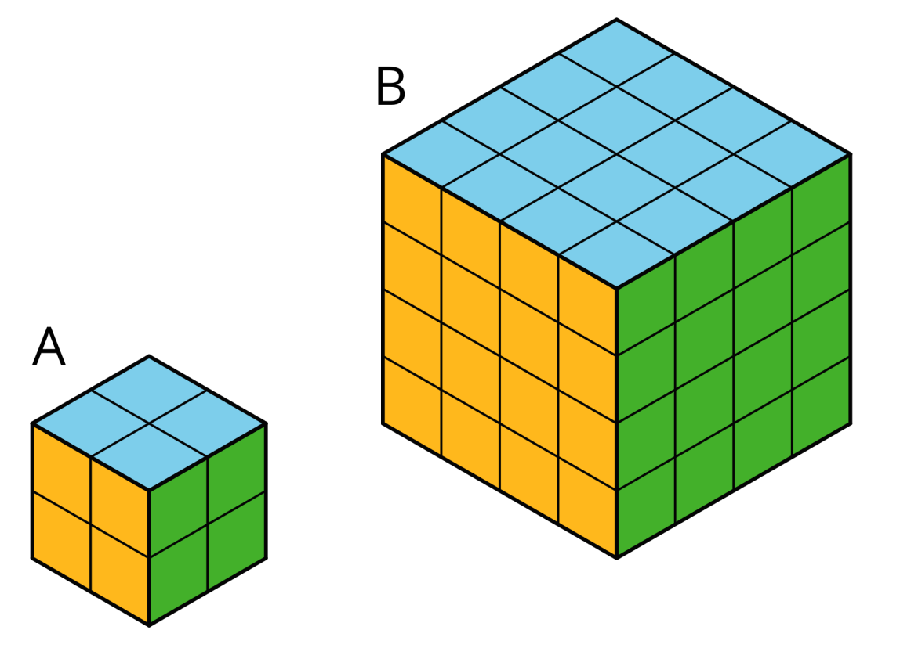

Solution
- No. Sample reasoning: The surface area of Cube A is 6⋅(2⋅2) or 24 square units. The surface area of Cube B is 6⋅(4⋅4) or 96 square units. The surface area of B is 4 times that of A.
- No. Sample reasoning: The volume of Cube B is 64 cubic units because 43=64. The volume of Cube A is 8 cubic units because 23=8. 64 is not twice as much as 8.

Lesson 9

Problem 1
This package of sliced cheese costs $2.97.
How much would a package with 18 slices cost at the same price per slice? Explain or show your reasoning.
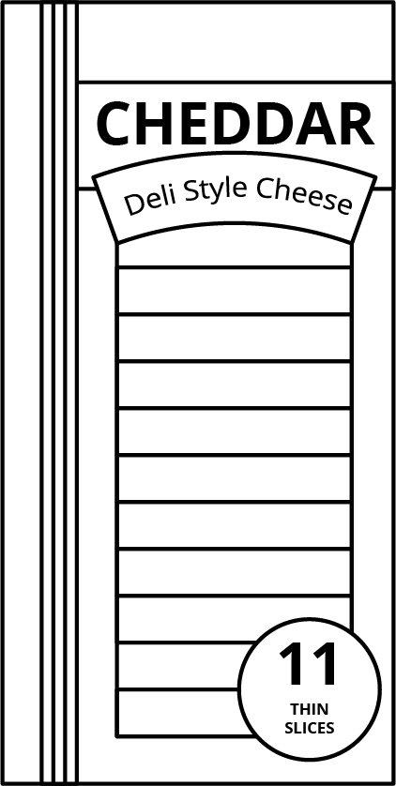

Solution
$4.86. Sample reasoning: The package of 11 slices costs $2.97, so this is 27 cents per slice. A package of 18 slices at 27 cents per slice would cost $4.86 because 18⋅($0.27)=4.86.

Problem 2
A copy machine can print 480 copies every 4 minutes. For each question, explain or show your reasoning.
- How many copies can it print in 10 minutes?
- A teacher printed 720 copies. How long did it take to print?

Solution
- 1,200 copies, because the rate is 120 copies per minute, and 120⋅10=1,200.
- 6 minutes, because 720÷120=6

Problem 3
Order these objects from heaviest to lightest. (Note: 1 pound = 16 ounces, 1 kilogram ≈ 2.2 pounds, and 1 ton = 2,000 pounds)
 | item | weight
row 1 | school bus | 9 tons
row 2 | horse | 1,100 pounds
row 3 | elephant | 5,500 kilograms
row 4 | grand piano | 15,840 ounces

Solution
school bus, elephant, horse, grand piano
 | item | weight | weight in pounds
row 1 | school bus | 9 tons | 18,000
row 2 | horse | 1,100 pounds | 1,100
row 3 | elephant | 5,500 kilograms | 13,000
row 4 | grand piano | 15,840 ounces | 990

Problem 4
(from Unit 3, Lesson 5)
Andre sometimes mows lawns on the weekend to make extra money. Two weeks ago, he mowed a neighbor’s lawn for 12 hour and earned $10. Last week, he mowed his uncle’s lawn for 32 hours and earned $30. This week, he mowed the lawn of a community center for 2 hours and earned $30.
Which jobs paid better than others? Explain your reasoning.

Solution
The first two jobs paid better. His neighbor and his uncle both paid $20 per hour. For his neighbor, an hour of lawn mowing pays 10⋅2 or $20. His uncle paid $30 per 32 hours, which means $10 every 12 hour and $20 every hour. The third job at the community center paid $15 per hour, since 30÷2=15.

Problem 5
(from Unit 3, Lesson 1)
Calculate and express your answer in decimal form.
- 12⋅17
- 34⋅200
- (0.2)⋅40
- (0.25)⋅60

Solution
- 8.5
- 150
- 8
- 15

Problem 6
(from Unit 1, Lesson 11)
- Decompose this polygon so that its area can be calculated. All measurements are in centimeters.
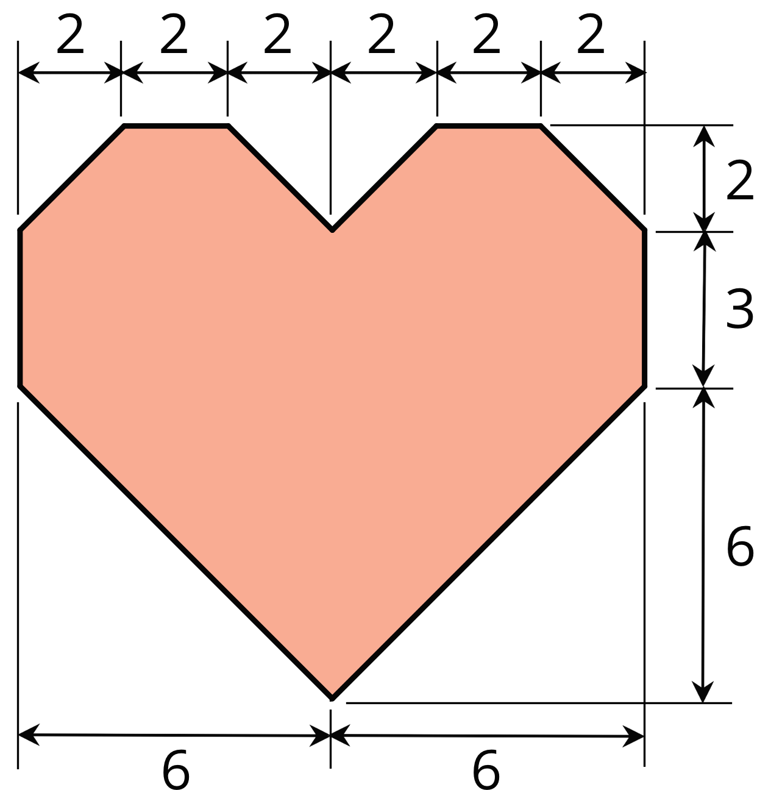
- Calculate its area. Organize your work so that it can be followed by others.

Solution
- Answers vary. One strategy is to decompose the polygon into triangles and rectangles and adding up their areas. Another is to enclose it with a rectangle, find its area, and subtract the unshaded right triangles from it.
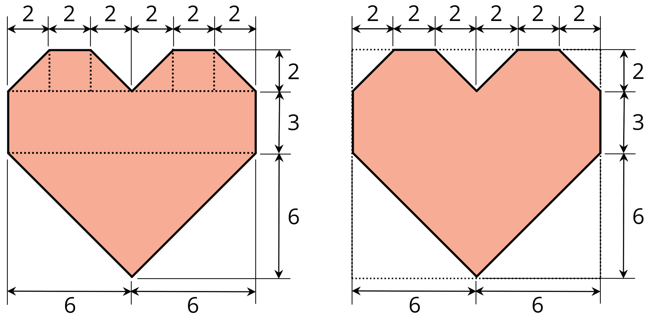
- 88 square centimeters. Reasonings vary.

Lesson 10

Problem 1
What percentage of a dollar is the value of each coin combination?
- 4 dimes
- 1 nickel and 3 pennies
- 5 quarters and 1 dime

Solution
- 40%
- 8%
- 135%

Problem 2
- List three different combinations of coins, each with a value of 30% of a dollar.
- List two different combinations of coins, each with a value of 140% of a dollar.

Solution
Answers vary. Sample response:
- 30 pennies, 6 nickels, or 3 dimes
- 140 pennies, 14 dimes, or 5 quarters and 3 nickels

Problem 3
The United States government used to make coins of many different values. For each coin, state its worth as a percentage of $1.
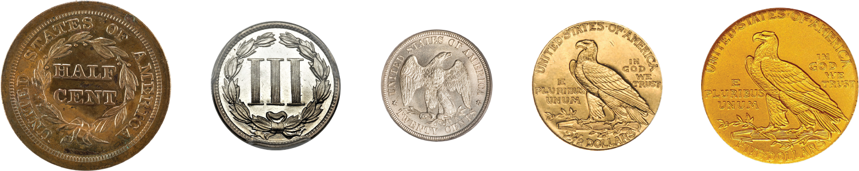
- 12 cent
- 3 cents
- 20 cents
- $212
- $5

Solution
- 12%
- 3%
- 20%
- 250%
- 500%

Problem 4
Complete the double number to line show percentages of $50.
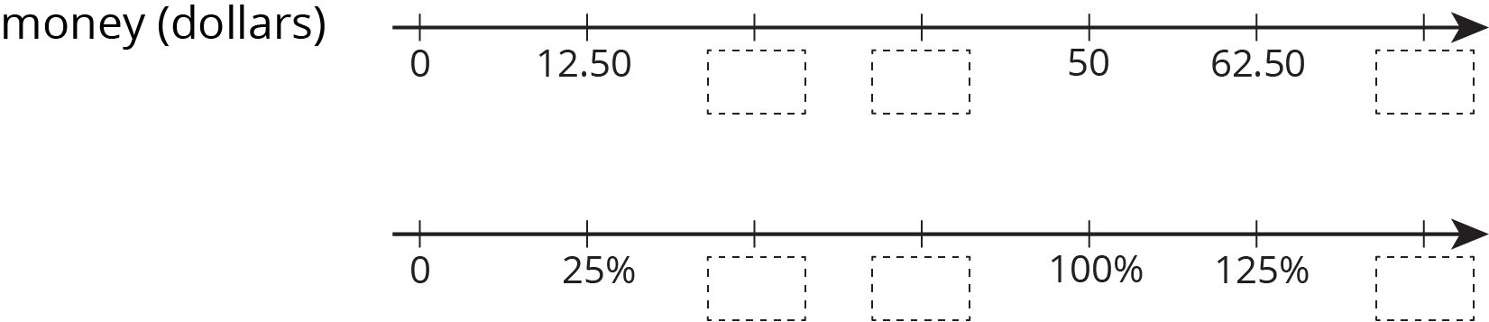

Solution
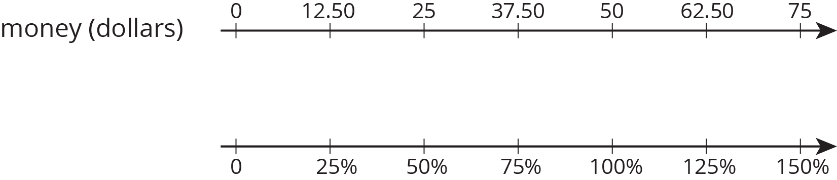

Problem 5
(from Unit 3, Lesson 9)
Elena bought 8 tokens for $4.40. At this rate:
- How many tokens could she buy with $6.05?
- How much do 19 tokens cost?

Solution
- 11 tokens
- $10.45

Problem 6
(from Unit 3, Lesson 8)
A snail travels 10 cm in 4 minutes. At this rate:
- How long will it take the snail to travel 24 cm?
- How far does the snail travel in 6 minutes?

Solution
- 9.6 minutes (or equivalent)
- 15 cm

Problem 7
(from Unit 3, Lesson 7)
- 3 tacos cost $18. Complete the table to show the cost of 4, 5, and 6 tacos at the same rate.
 | number of tacos | cost in dollars | rate in dollars per taco
row 1 | 3 | 18
row 2 | 4
row 3 | 5
row 4 | 6
- b. If you buy t tacos for cdollars, what is the unit rate?

Solution

 | number of tacos | cost in dollars | rate in dollars per taco
row 1 | 3 | 18 | 6
row 2 | 4 | 24 | 6
row 3 | 5 | 30 | 6
row 4 | 6 | 36 | 6
- ct dollars per taco or tc tacos per dollar.

Lesson 11

Problem 1
Solve each problem. If you get stuck, consider using the double number lines.
- During a basketball practice, Mai attempted 40 free throws and was successful on 25% of them. How many successful free throws did she make?
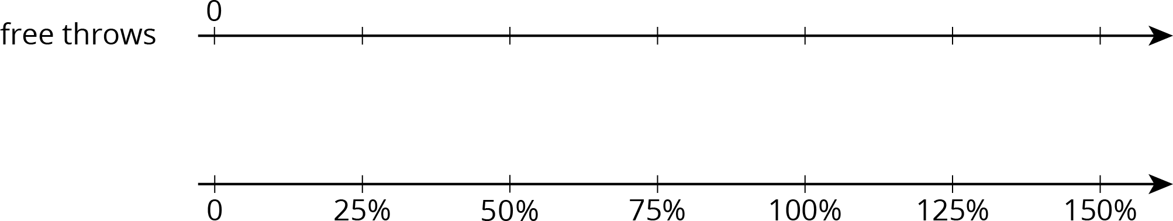
- Yesterday, Priya successfully made 12 free throws. Today, she made 150% as many. How many successful free throws did Priya make today?

Solution
- 10 free throws
- 18 free throws

Problem 2
A 16-ounce bottle of orange juice says it contains 200 milligrams of vitamin C, which is 250% of the daily recommended allowance of vitamin C for adults. What is 100% of the daily recommended allowance of vitamin C for adults?
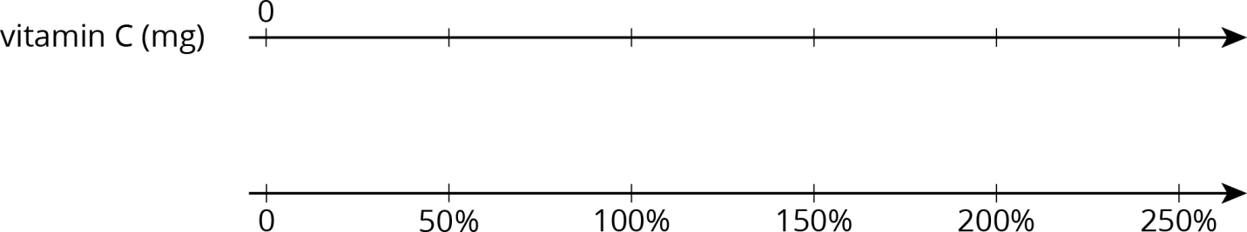

Solution
200 mg. Explanations vary. Sample explanation: 80 mg is 100% of the daily recommended allowance. The double number line can be used to show this: 80 is above 100%. So half of 80 is above half of 100%, that is, 40 is above 50%. Also, 2 times 80 is above 2 times 100%, that is, 160 is above 200%. So, the number above 250% is the number above 50% plus the number above 200%, which is 40 plus 160.
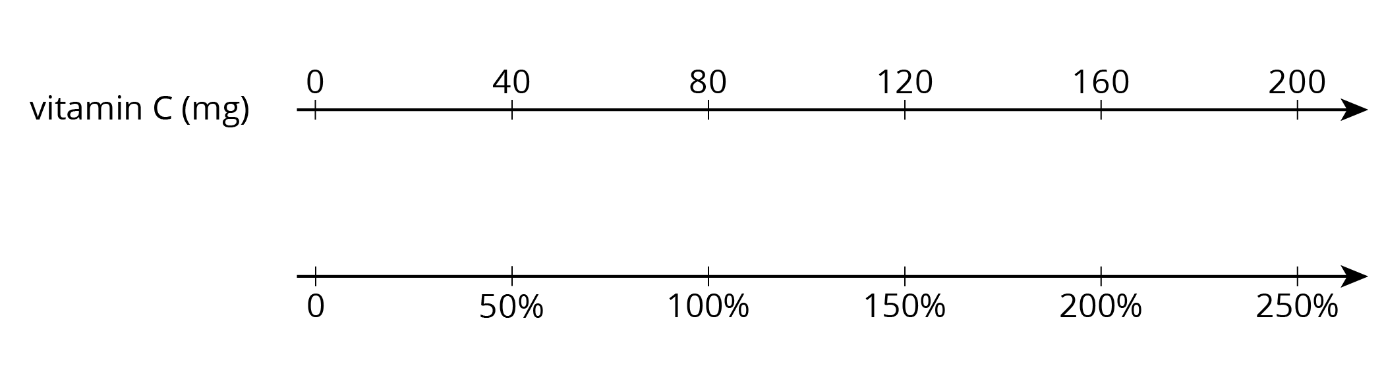

Problem 3
At a school, 40% of the sixth-grade students said that hip-hop is their favorite kind of music. If 100 sixth-grade students prefer hip hop music, how many sixth-grade students are at the school? Explain or show your reasoning.

Solution
250. Explanations vary. Possible explanation:
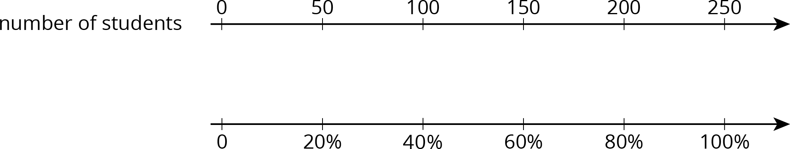

Problem 4
(from Unit 3, Lesson 9)
Diego has a skateboard, scooter, bike, and go-cart. He wants to know which vehicle is the fastest. A friend records how far Diego travels on each vehicle in 5 seconds. For each vehicle, Diego travels as fast as he can along a straight, level path.
 | vehicle | distance traveled
row 1 | skateboard | 90 feet
row 2 | scooter | 1,020 inches
row 3 | bike | 4,800 centimeters
row 4 | go-cart | 0.03 kilometers
- 100 inches equal 254 centimeters. What is the distance each vehicle traveled in centimeters?
- Rank the vehicles in order from fastest to slowest.

Solution
- Skateboard: 2,743.2. Scooter: 2,590.8. Bike: 4,800. Go-cart: 3,000.
- Bike, go-cart, skateboard, scooter

Problem 5
(from Unit 3, Lesson 7)
It takes 10 pounds of potatoes to make 15 pounds of mashed potatoes. At this rate:
- How many pounds of mashed potatoes can they make with 15 pounds of potatoes?
- How many pounds of potatoes are needed to make 50 pounds of mashed potatoes?

Solution
- To find the amount of mashed potatoes, multiply the amount of potatoes by 32, 2212 pounds of mashed potatoes (or equivalent).
- To find the potatoes, multiply the amount of mashed potatoes by 23, 3313pounds of potatoes (or equivalent).

Lesson 12

Problem 1
Here is a tape diagram that shows how far two students walked.
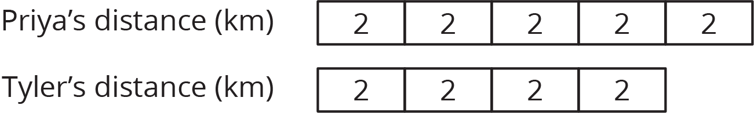

- What percentage of Priya’s distance did Tyler walk?
- What percentage of Tyler’s distance did Priya walk?

Solution
- 80%
- 125%

Problem 2
A bakery makes 40 different flavors of muffins. 25% of the flavors have chocolate as one of the ingredients. Draw a tape diagram to show how many flavors have chocolate and how many don’t.

Solution
Each unit in the tape diagram represents 25%, so 10 have chocolate and 30 do not.
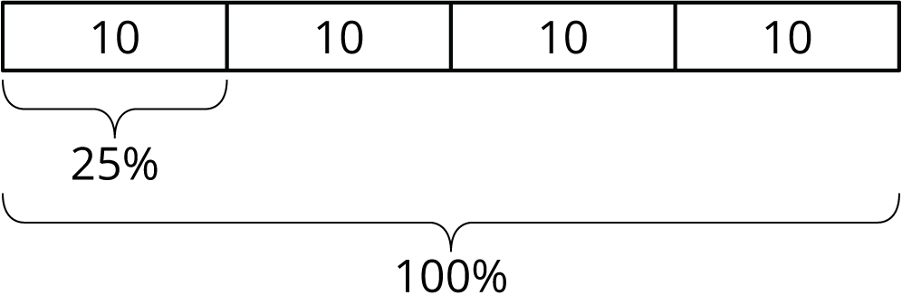

Problem 3
There are 70 students in the school band. 40% of them are sixth graders, 20% are seventh graders, and the rest are eighth graders.
- How many band members are sixth graders?
- How many band members are seventh graders?
- What percentage of the band members are eighth graders? Explain your reasoning.

Solution
- 28 (70⋅0.4=28)
- 14 (70⋅0.2=14)
- 40% because the other percentages add up to 60% and that leaves 40%, because 100−60=40.

Problem 4
(from Unit 3, Lesson 11)
Jada has a monthly budget for her cell phone bill. Last month she spent 120% of her budget, and the bill was $60. What is Jada’s monthly budget? Explain or show your reasoning.

Solution
$50. Strategies vary. Sample reasoning: If 120% is 60, then 20% is 10, which I get by multiplying each by 16. If 20% is 10, then 100% is 50, which I get by multiplying each by 5.

Problem 5
(from Unit 3, Lesson 9)
Which is a better deal, 5 tickets for $12.50 or 8 tickets for $20.16? Explain your reasoning.

Solution
5 tickets for $12.50 is a better deal. 5 tickets for $12.50 equals a unit rate of $2.50 per ticket, (12.50÷5=2.50), and 8 tickets for $20.16 equals a unit rate of $2.52 per ticket, (12.50÷8=2.52).

Problem 6
(from Unit 3, Lesson 8)
An athlete runs 8 miles in 50 minutes on a treadmill. At this rate:
- How long will it take the athlete to run 9 miles?
- How far can the athlete run in 1 hour?

Solution
- 56.25 minutes (or equivalent)
- 9.6 miles (or equivalent)

Lesson 13

Problem 1
- How can you find 50% of a number quickly in your head?
- Andre lives 1.6 km from school. What is 50% of 1.6 km?
- Diego lives 12 mile from school. What is 50% of 12 mile?

Solution
- Answers vary. Sample response: Divide the number by 2 (or multiply it by 12).
- 0.8 km (or equivalent)
- 14 mile (or equivalent)

Problem 2
There is a 10% off sale on laptop computers. If someone saves $35 on a laptop, what was its original cost? If you get stuck, consider using the table.
 | savings (dollars) | percentage
row 1 | 35 | 10
row 2 | ? | 100

Solution
$350

Problem 3
Explain how to calculate these mentally.
- 15 is what percentage of 30?
- 3 is what percentage of 12?
- 6 is what percentage of 10?

Solution
Answers vary. Sample response:
- 50%. 15 is 12 of 30, so that is 50%.
- 25%. 3 is 14 of 12, so that is 25%.
- 60%. 610 is the same as 35, and each 15 is 20%.

Problem 4
Noah says that to find 20% of a number he divides the number by 5. For example, 20% of 60 is 12, because 60÷5=12. Does Noah’s method always work? Explain why or why not.

Solution
Yes. Answers vary. Sample response: 20% of a number is 20100 times the number and 20100=15. Multiplying by 15 gives the same result as dividing by 5.

Problem 5
(from Unit 3, Lesson 10)
Diego has 75% of $10. Noah has 25% of $30. Diego thinks he has more money than Noah, but Noah thinks they have an equal amount of money. Who is right? Explain your reasoning.

Solution
They each have $7.50 ( 10⋅0.75=7.50 and 30⋅0.25=7.50).

Problem 6
(from Unit 3, Lesson 8)
Lin and Andre start walking toward each other at the same time from opposite ends of 22-mile walking trail. Lin walks at a speed of 2.5 miles per hour. Andre walks at a speed of 3 miles per hour.
Here is a table showing the distances traveled and how far apart Lin and Andre were over time. Use the table to find how much time passes before they meet.
 | elapsed time (hour) | Lin’s distance (miles) | Andre’s distance (miles) | distance apart (miles)
row 1 | 0 | 0 | 0 | 22
row 2 | 1 | 2.5 | 3 | 16.5
row 3
row 4
row 5 |  |  |  | 0

Solution
4 hours. Possible strategy:
 | elapsed time (hour) | Lin’s distance (miles) | Andre’s distance (miles) | distance apart (miles)
row 1 | 0 | 0 | 0 | 22
row 2 | 1 | 2.5 | 3 | 16.5
row 3 | 2 | 5 | 6 | 11
row 4 | 3 | 7.5 | 9 | 5.5
row 5 | 4 | 10 | 12 | 0

Lesson 14

Problem 1
For each problem, explain or show your reasoning.
- 160 is what percentage of 40?
- 40 is 160% of what number?
- What number is 40% of 160?

Solution
Reasoning varies. Sample responses:
- 400%, because 4⋅40=160.
- 25, because 40÷8=5 is 20% of that number, and 5⋅5=25 is 100% of that number.
- 64, because 10% of 160 is 16, and 4⋅16=64.

Problem 2
A store is having a 20%-off sale on all merchandise. If Mai buys one item and saves $13, what was the original price of her purchase? Explain or show your reasoning.

Solution
$65. Possible reasoning:
Place $13 at 20%. To get from 20% to 100%, multiply by 5. Therefore, also multiply 13 by 5.

Problem 3
The original price of a scarf was $16. During a store-closing sale, a shopper saved $12 on the scarf. What percentage discount did she receive? Explain or show your reasoning.

Solution
75%. Possible explanations:
- 12÷16=75100 (or 12÷16=0.75)

 | value (dollars) | percentage
row 1 | 16 | 100
row 2 | 12 | 75

Problem 4
Select all the expressions whose value is larger than 100.
- 120% of 100
- 50% of 150
- 150% of 50
- 20% of 800
- 200% of 30
- 500% of 400
- 1% of 1,000

Solution
A, D, F

Problem 5
(from Unit 3, Lesson 8)
An ant travels at a constant rate of 30 cm every 2 minutes.
- At what pace does the ant travel per centimeter?
- At what speed does the ant travel per minute?

Solution
- The pace is 115 of a minute per centimeter.
- The speed is 15 centimeters per minute.

Problem 6
(from Unit 3, Lesson 4)
Is 312 cups more or less than 1 liter? Explain or show your reasoning. (Note: 1 cup ≈ 236.6 milliliters)

Solution
Less. Explanations vary. Possible explanation:
 | cups | milliliters
row 1 | 1 | 236.6
row 2 | 0.5 | 118.3
row 3 | 3 | 709.8
row 4 | 3.5 | 828.1

Problem 7
(from Unit 3, Lesson 2)
Name a unit of measurement that is about the same size as each object.
- The distance of a doorknob from the floor is about 1 _____________.
- The thickness of a fingernail is about 1 _____________.
- The volume of a drop of honey is about 1 _____________.
- The weight or mass of a pineapple is about 1 _____________.
- The thickness of a picture book is about 1 _____________.
- The weight or mass of a buffalo is about 1 _____________.
- The volume of a flower vase is about 1 _____________.
- The weight or mass of 20 staples is about 1 _____________.
- The volume of a melon is about 1 _____________.
- The length of a piece of printer paper is about 1 _____________.

Solution
- Yard or meter
- Millimeter
- Milliliter
- Kilogram or pound
- Centimeter or inch
- Ton
- Cup, quart, or liter
- Gram
- Gallon
- Foot

Lesson 15

Problem 1
- To find 40% of 75, Priya calculates 25⋅75. Does her calculation give the correct value for 40% of 75? Explain or show how you know.
- If x represents a number, does 25⋅x always represent 40% of that number? Explain your reasoning.

Solution
- Yes. 40% is 0.4, and (0.4)⋅75=30. Using Priya’s method: 25⋅75=30.
- Yes. 40% of x is 40100⋅x. This is the same as 25⋅x, since 40100 and 25 are equivalent fractions.

Problem 2
Han spent 75 minutes practicing the piano over the weekend. For each question, explain or show your reasoning.
- Priya practiced the violin for 152% as much time as Han practiced the piano. How long did she practice?
- Tyler practiced the clarinet for 64% as much time as Han practiced the piano. How long did he practice?

Solution
- 114 minutes. Sample reasoning: 152% of 75 minutes is 152100⋅75=114.
- 48 minutes. Sample reasoning: 64% of 75 minutes is 64100⋅75=48.

Problem 3
Last Sunday 1,575 people visited the amusement park. 56% of the visitors were adults, 16% were teenagers, and 28% were children ages 12 and under. Find the number of adults, teenagers, and children that visited the park.

Solution
938 adults, 268 teenagers, and 469 children

Problem 4
Order from greatest to least:
- 55% of 180
- 300% of 26
- 12% of 700

Solution
55% of 180, 12% of 700, 300% of 26.

Problem 5
(from Unit 3, Lesson 14)
Complete each statement.
- 20% of 60 is ________
- 25% of ________ is 6
- ________% of 100 is 14
- 50% of 90 is ________
- 10% of ________ is 7
- 30% of 70 is ________

Solution
- 12
- 24
- 14
- 45
- 70
- 21

Problem 6
(from Unit 3, Lesson 9)
A shopper needs 24 sandwich rolls. The store sells identical rolls in 2 differently sized packages. They sell a six-pack for $5.28 and a four-pack for $3.40. Should the shopper buy 4 six-packs or 6 four-packs? Explain your reasoning.

Solution
6 four-packs is a better deal. The rolls in the six-pack are being sold at a rate of 88 cents each, because 5.28÷6=0.88. The rolls in the four-pack are being sold at a rate of 85 cents each, because 3.40÷4=0.85. The four-packs are a better deal, because the sandwich rolls have a cheaper unit rate.

Problem 7
(from Unit 2, Lesson 15)
On a field trip, there are 3 chaperones for every 20 students. There are 92 people on the trip. Answer these questions. If you get stuck, consider using a tape diagram.
- How many chaperones are there?
- How many children are there?

Solution
- 12
- 80

Lesson 16

Problem 1
A sign in front of a roller coaster says "You must be 40 inches tall to ride." What percentage of this height is:
- 34 inches?
- 54 inches?

Solution
- 85%
- 135%

Problem 2
At a hardware store, a tool set normally costs $80. During a sale this week, the tool set costs $12 less than usual. What percentage of the usual price is the savings? Explain or show your reasoning.

Solution
Reasoning varies. Sample response: 15%, because 12÷80=320=15100.

Problem 3
A bathtub can hold 80 gallons of water. The faucet flows at a rate of 4 gallons per minute. What percentage of the tub will be filled after 6 minutes?

Solution
30%, because the tub will hold 24 gallons after 6 minutes, and 24 is 30% of 80.

Problem 4
(from Unit 3, Lesson 15)
The sale price of every item in a store is 85% of its usual price.
- The usual price of a backpack is $30, what is its sale price?
- The usual price of a sweatshirt is $18, what is its sale price?
- The usual price of a soccer ball is $24.80, what is its sale price?

Solution
- $25.50
- $15.30
- $21.08

Problem 5
(from Unit 3, Lesson 9)
A shopper needs 48 hot dogs. The store sells identical hot dogs in 2 differently sized packages. They sell a six-pack of hot dogs for $2.10, and an eight-pack of hot dogs for $3.12. Should the shopper buy 8 six-packs, or 6 eight-packs? Explain your reasoning.

Solution
He should buy 8 six-packs. The hot dogs in the six-pack are being sold at a rate of 35 cents each, because 2.10÷6=0.35. The hot dogs in the eight-pack are being sold at a rate of 39 cents each, because 3.12÷8=0.39. The six-packs are a better deal, because the hot dogs have a cheaper unit rate.

Problem 6
(from Unit 3, Lesson 4)
Elena is 56 inches tall.
- What is her height in centimeters? (Note: 100 inches = 254 centimeters)
- What is her height in meters?

Solution
- 142.24 centimeters
- 1.42 meters

