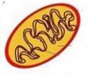
1. What kind of cell organelle is this?
Correct Answer: Mitochondrion

2. Which organelle would NOT be found in animal cells?
Correct Answer: chloroplast

3. Which of the following statements is not part of the cell theory?
Correct Answer: Only animal cells are composed of cells.

4. The basic unit of structure and function in a living things.
Correct Answer: cell

5. What organelle is considered to be the “gatekeeper” for all cells and allows materials in and out of the cell?
Correct Answer: Cell Membrane

6. What organelle releases energy for a cell?
Correct Answer: Mitochondria
7. B = brown fur b = white fur
In the punnett square, what is the probability for white fur?
Correct Answer: 50%

8. This thin layer protects the cell and regulates what substances enter and leave the cell.
Correct Answer: cell membrane

9. What cell part is NOT found in all cells?
Correct Answer: Cell Wall

10. The second part of Cell Theory states: "All living things are made up of cells."
Correct Answer: True

11. In mitosis, the two resulting cells are
Correct Answer: identical to the starting cell and identical to each other.

12. Why do we need meiosis?
Correct Answer: To halve the number of chromosomes going into sex cells

13. A gel-like fluid in which many different organelles are found.
Correct Answer: cytoplasm
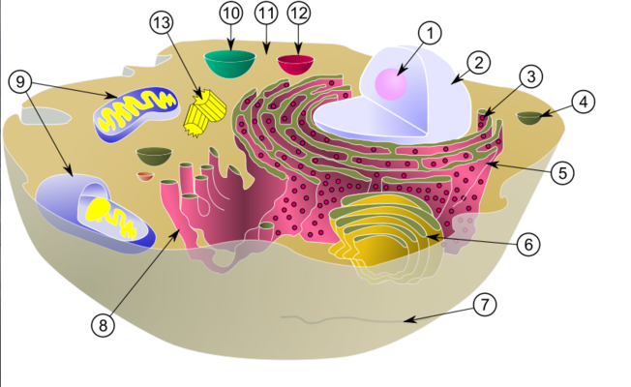

14. Name structure #6.
Correct Answer: Golgi body

15. Every cell in every living thing comes from another cell that
Correct Answer: divides

16. In what organelle is the genetic material DNA found inside?
Correct Answer: Nucleus

17. Plant cells have what 2 organelles that animal cells do not have?
Correct Answer: cell wall and chloroplast

18. In plants, tall (T) is dominant to short (t). Perform the following cross: Tt x Tt. What is the probability of producing a short plant?
Correct Answer: 25%

19. Fruit fly body cells have 8 chromosomes. After mitosis, you would expect a resulting fruit fly daughter cell to have ...
Correct Answer: 8 chromosomes.

20. Crossing over helps promote
Correct Answer: genetic variation

21. the arrangement of parts in an organism
Correct Answer: structure

22. The scientific study of genes being passed by generation.
Correct Answer: Genetics
23. T - tall and t = short
In the punnett square below, what belongs in the missing square
Correct Answer: tt

24. The passing of genetic traits from parent to offspring:
Correct Answer: heredity

25. This sac with the cytoplasm stores water, food, waste, products and other materials.
Correct Answer: vacuole

26. who created the idea of the cell
Correct Answer: Robert Hooke
27. Name structure #5.
Correct Answer: rough ER

28. Membrane bound sacs that are filled with fluid, they store water, food, and waste
Correct Answer: Vacuoles

29. G = green, g = yellow
The genotype for a yellow plant is...
Correct Answer: gg

30. What organelle surrounds and supports plant cells?
Correct Answer: Cell Wall

31. Why is DNA important?
Correct Answer: it serves as the blueprint for traits of all living things

32. What do all living organisms contain?
Correct Answer: cells

33. What is another reason we need meiosis?
Correct Answer: So the offspring has genes from both parents

34. Rocks are not living because
Correct Answer: they are not made of cells

35. These small structures function as factories to produce proteins.
Correct Answer: ribosomes
36. Name structure #1.
Correct Answer: nucleus

37. Two mice heterozygous for red eyes mate. What is the expected genotypic ratio of their offspring?
Correct Answer: 1 RR: 2 Rr: 1 rr

38. The site of photosynthesis
Correct Answer: chloroplast

39. What makes an adult squirrel bigger than a baby squirrel?
Correct Answer: More cells

40. Which organelle makes proteins?
Correct Answer: ribosomes

41. Who is considered the "father of genetics"?
Correct Answer: Gregor Mendel

42. A human usually has xx amount of chromosomes.
Correct Answer: 46
43. Name structure #9.
Correct Answer: mitochondria

44. The process by which the nucleus is divided equally between two new cells
Correct Answer: mitosis

45. Which 2 organelles are in plants and animals?
Correct Answer: cell membrane and cytoplasm

46. Two brown eyed parents (Bb) have a baby. What is the chance the baby is blue eyed?
Correct Answer: 25%

